CERTIGUARD: SECURE DOCUMENT ISSUANCE
AND VERIFICATION FRAMEWORK FOR BARANGAY TAGURANAO



BACHELOR OF SCIENCE IN INFORMATION TECHNOLOGY
NORTH VALLEY COLLEGE FOUNDATION INC., LANAO, KIDAPAWAN CITY

September 2026

CHAPTER I
INTRODUCTION
Background of the Study
In the Philippines, barangay governance plays a vital role in delivering essential public services to local communities. One of the most critical functions of barangay administration is the issuance of official certificates, including Barangay Clearances, Certificates of Indigency, and Certificates of Residency. These documents serve as fundamental requirements for employment, educational enrollment, government assistance programs, and various legal transactions. However, the current manual process of issuing these certificates in many barangays across the country remains inefficient and vulnerable to numerous challenges.
The traditional method of certificate issuance typically relies on basic word processing tools such as Microsoft Word or Excel, where barangay staff manually type citizen information, print physical copies, and affix wet signatures and dry seals. This manual workflow creates significant problems for both residents and barangay administrators. Residents often endure long queues and waiting times, while administrative staff face excessive workloads and the risk of data entry errors. Moreover, manual record-keeping using physical logbooks makes it difficult to track issued certificates and maintain accurate historical records.
Perhaps the most alarming issue with the current system is its extreme vulnerability to document forgery. Since certificates are printed on ordinary paper with easily replicable signatures and seals, malicious individuals can manipulate these documents using basic image editing software such as Adobe Photoshop. A person can simply download a legitimate certificate image, alter the citizen's name, expiration dates, or other critical details, and present the forged document to employers, schools, or government agencies. Counterfeit dry seals can be purchased online for minimal cost, further compromising document authenticity. This widespread forgery undermines public trust in barangay-issued documents and creates risks for institutions that rely on these certificates for verification purposes.

Recognizing these critical issues, the researchers propose the development of "CertiGuard: Secure Document Issuance and Verification Framework for Barangay Taguranao." This innovative system aims to transform the barangay's certificate issuance process through digital transformation. The system leverages modern web technologies and cryptographic security features to create a secure, efficient, and transparent document management platform. Unlike the traditional reliance on physical paper aesthetics, CertiGuard shifts the proof of document validity to real-time cryptographic database verification, completely eliminating the vulnerabilities associated with manual certificate issuance.
The system provides an accessible web-based portal where residents can securely request certificates online, eliminating the need for physical presence during application submission. Barangay administrators benefit from a streamlined processing console that centralizes all certificate management tasks. Most importantly, CertiGuard implements a robust cryptographic QR code verification mechanism. Each issued certificate receives a unique 64-character SHA-256 hash signature embedded in a QR code. This allows third-party institutions to instantly verify certificate authenticity by scanning the QR code, which retrieves the original document data directly from the secure database, exposing any tampering attempts.
Additionally, the system integrates an automated SMS notification gateway that provides real-time transaction updates to residents. This feature enhances communication transparency by automatically informing applicants of their document status, including approval notifications, control numbers, and download instructions. The SMS functionality ensures that residents remain informed throughout the certificate issuance process, reducing their need to physically visit the barangay hall for status inquiries.
By implementing this comprehensive digital framework, CertiGuard addresses the fundamental weaknesses of manual certificate issuance while establishing a new standard for document security in local governance. The system contributes to the broader goal of digital transformation in Philippine local government units, aligning with national initiatives to modernize public service delivery through information and communications technology.
Statement of the Problem
Based on actual observations and direct interviews with barangay officials and residents of Barangay Taguranao, the following problems were identified:
- Inefficient Processing: Manual certificate issuance using word processors and logbooks causes delays, data errors, and poor administrative tracking and reporting.
- Resident Inconvenience: Residents face long queues, mandatory in-person visits during office hours, and no real-time status updates for their requests.
- Security Vulnerabilities: Paper certificates lack anti-counterfeiting features, making them easily forgeable and undermining institutional trust.

Objectives of the Study
This study aims to develop a Secure Document Issuance and Verification Framework for Barangay Taguranao. Specifically, the study aims to:
- To develop a secure web-based document issuance system tailored for local barangay governance that automates the online request, administrative processing, and secure retrieval of barangay certificates.
- To establish an automated cross-platform communication node through an integrated SMS gateway to provide real-time transactional transparency and status notifications to residents.
- To implement a cryptographic QR code verification engine utilizing secure SHA256 hashing algorithms to ensure absolute document authenticity and mitigate document forgery.

Scope and Delimitation of the Study
The development of CertiGuard is carried out for Barangay Taguranao, focusing on the automation and digitization of the certificate issuance process. The system covers the three most frequently requested certificates in the barangay: Barangay Clearance, Certificate of Indigency, and Certificate of Residency. The scope includes user registration, online certificate application, administrative processing, secure PDF generation with embedded QR codes, automated SMS notifications, and third-party verification portal.
The project is a cloud-based web application accessible through web browsers on various devices, including desktop computers and smartphones. The system leverages Supabase, a managed backend-as-a-service platform, to handle database storage, user authentication, and file management, requiring a stable internet connection for both resident and administrative functions. The system implements cryptographic security features, including SHA-256 hashing for document integrity verification and QR code embedding for easy authenticity checks by external parties.
The delimitations of the study are as follows: The system does not include public community forum boards, online payment portals, artificial intelligence-based form auditing, or biometric registration features. The system's verification portal displays only non-sensitive information compliant with Republic Act No. 10173 (Data Privacy Act of 2012), masking sensitive personal details such as contact numbers and specific residential addresses. The prototype testing is conducted using simulated resident profiles (3 to 5 test accounts) rather than actual citizen data to maintain data privacy and research ethics compliance. All generated certificates during the prototype phase include a prominent watermark stating "FOR ACADEMIC PROTOTYPE TESTING ONLY" to ensure ethical use of the system.

Significance of the Study
This study is significant in providing a technologically reliable solution to the common problems of manual certificate issuance at Barangay Taguranao. Its benefits extend to various stakeholders:

Barangay Taguranao Administration.
This system is beneficial to the barangay for it will digitize and streamline certificate issuance operations, reduce administrative workload, ensure document authenticity, and provide better monitoring and record-keeping capabilities for effective governance and planning.
Barangay Residents.
This system will be beneficial to residents by providing a more accessible and convenient method of requesting certificates. Residents can apply online, receive realtime status updates via SMS, and download their certificates without the need for multiple physical visits to the barangay hall, saving time and effort.
Barangay Officials and Staff.
This system will bring benefits to barangay officials and staff by minimizing their workloads, reducing human errors in certificate processing, and providing them with efficient tools for managing resident records, tracking applications, and generating accurate reports for administrative purposes.
External Institutions (Employers, Schools, Government Agencies).
The system provides a reliable verification mechanism that enables external institutions to instantly authenticate certificates presented by residents. By scanning the QR code on the certificate, they can verify document authenticity directly from the barangay's secure database, reducing the risk of accepting forged documents.
Future Researchers.
This study will serve as a reference and will help future researchers who will be working on developing or improving similar document management and verification systems. The study provides relevant information, data, and methodologies that can guide the development of more efficient and secure systems. Moreover, this study will help future researchers identify best practices, avoid common pitfalls, and develop new ideas to improve the efficiency and effectiveness of digital governance systems.

Chapter II
REVIEW OF RELATED LITERATURE
This chapter provides an overview of relevant literature and studies that will guide the system development and data collection process.
Based on the study conducted by Villanueva, L.G.V., Esteves, K.J.G., & De Guzman, K.D. (2026), transforming local governance through AI and data analytics in Barangay Information Management Systems. This study emphasizes the application of electronic systems to revolutionize local governance in the Philippines, cutting red tape in administrative workflows and improving citizen engagement. The Barangay Information Management System (BIMS) adopts emerging technologies such as blockchain to secure records and AI-powered automation for triage services. The system includes embedded analytics modules and real-time dashboards that provide officials with tools to monitor service trends and assess program impact. Usability testing returned a high SUS score of 95.67, indicating a perfect fit with user needs.
According to Adithia, M.T. (2026), document verification and authentication by using password-based digital signatures with QR codes. This study presents a secure digital-signature framework for document authentication using QR Codes, combining RSA 2048-bit for digital signing, SHA-256 for document-integrity verification, and password-based AES encryption to protect the signer's private key. Functional testing demonstrates that the system accurately authenticates signer identities, detects any modification to document content, and rejects invalid or non-signature QR Codes. These results confirm that the combination of RSA 2048, SHA-256 hashing, and passwordderived AES encryption effectively ensures confidentiality of private keys while preserving document integrity and authenticity.
Based on the study of Arifin, Z. (2026), development of a web-based TOEFL ecertificate system with QR code verification and AES–SHA-256 security framework. This study indicates that AES encryption is applied to safeguard sensitive data, while SHA256 hashing ensures the integrity and authenticity of certificate information. The system enables real-time verification of certificates through QR code scanning, providing a secure alternative to traditional paper-based certificates.
As mentioned by IRE Journals (2026), document verification system using QR code method. This paper presents the design and development of a Secure Document Verification System using QR Code Method built using modern full-stack web technologies. The proposed system allows authorized administrators to upload and generate verified documents embedded with unique QR codes containing encrypted verification data. Each generated QR code acts as a secure digital signature that can be scanned by employers, institutions, or verification authorities to instantly validate the authenticity of the document. QR code generation is performed using secure hashing and unique document identifiers, while verification is completed through real-time database matching.
According to the study by the authors of Cangbagsa Digital Barangay Information System (2026), an academic extension-driven solution for enhancing barangay operations in rural Philippines. This study details the development and implementation of the Cangbagsa Digital Barangay Information System (CDBIS), an academically driven extension solution that addresses inefficiencies in barangay operations. Prior challenges included processing documents within 2–3 days, data inaccuracies, and limited service accessibility. The system was developed using a web-based, multi-tier architecture that integrates a user-friendly interface, role-based business logic, a centralized database, and secure server infrastructure. CDBIS significantly improved governance, reducing processing time by 75% and improving data accuracy by 88%.
Based on the study of the authors of Webyu system (2025), digital barangay: Ayos Lomboy's web-based management system for Barangay Yuson. This study developed Webyu, a web-based Barangay Information Management System designed to automate workflows, centralize data, and improve service delivery. The system successfully streamlined administrative tasks, reduced processing times, and enhanced data accessibility for both barangay officials and residents. Technical quality was rigorously assessed using ISO 25010 standards, evaluating functionality, performance efficiency, usability, and security. Results demonstrated exceptional performance across all ISO 25010 criteria with particularly high scores in maintainability and security.
According to Boranbayev, A. et al. (2021), development and design of a library information system intended for automation of processes in higher education institution. While focused on libraries, this paper presents the architecture and design of an Information System created to automate operations including ordering, cataloging, electronic catalog searches, reservations, and inventory management. Additionally, the system offers users access to the electronic catalog and documents through a web-based interface. This demonstrates the transferability of web-based automation principles from library systems to barangay certificate management systems.
Based on the study of Echedom, A.U., & Okuonghae, O. (2021), transforming academic library operations in Africa with artificial intelligence: Opportunities and challenges. This study highlights how academic libraries have embraced various technologies over time to deliver swift, effective, and efficient services. The research concludes that embracing modern technology is essential for providing strong services within the Fourth Industrial Revolution (4IR). This principle applies equally to barangay governance, where digital transformation through ICT can significantly enhance service delivery and operational efficiency.
According to the Department of the Interior and Local Government (2026), DILG launched nationwide digital document management system for LGUs. The DILG launched the Document Management System for Local Government Units (DMS4LGUs), a nationwide digital platform designed to update records management and strengthen efficiency, transparency, and accountability in local governance. This national initiative aligns with and supports localized efforts such as CertiGuard in modernizing public service delivery through information and communications technology at the barangay level.
Based on the study of IJERT (2026), comparison of traditional and digital barangay systems in the Philippines. This study examined the comparison between traditional manual systems and digital barangay information systems in the Philippines, focusing on their effectiveness, efficiency, accuracy, data security, and implementation challenges. It recommended adopting user-friendly technologies, improving digital literacy, strengthening cybersecurity practices, and implementing hybrid systems to support the gradual digital transformation of barangay governance in the Philippines.
CHAPTER III
METHODOLOGY
This chapter presents the research methodology, architectural framework, technical specifications, locale, organizational structure, data dictionary, process modeling, and disaster recovery plan for CertiGuard: Secure Document Issuance and Verification Framework for Barangay Taguranao. The methodology establishes an end-to-end engineering roadmap that transitions manual, paper-dependent barangay workflows into a verifiable, privacy-compliant, and cryptographically secured digital ecosystem.
Technicality of the Project
The proposed system, entitled "CertiGuard: Secure Document Issuance and Verification Framework for Barangay Taguranao," is a cloud-native, web-based platform specifically engineered to automate document application, administrative verification, and public document authentication. The framework governs the lifecycle of the three most vital certificates issued by local government units: the Barangay Clearance, Certificate of Indigency, and Certificate of Residency. It fundamentally mitigates the risks of manual administrative overhead, physical document wear, and unauthorized digital forgery.
Access to the administrative and citizen-facing services is governed through a role-based authentication gateway requiring validated email credentials and encrypted passwords. Upon successful credential validation, the system dynamically routes authenticated actors into role-customized workspaces:
- Resident Portal: Empowers constituents to register their citizen profiles, upload government-issued valid IDs for residency vetting, submit certificate applications with declared legal purposes, monitor processing status in real time, and download verified digital PDF certificates without requiring repeated physical visits to the barangay hall.
- Administrative Processing Console: Furnishes the Punong Barangay, Barangay Secretary, and authorized staff with a unified dashboard to inspect resident credentials, audit uploaded valid IDs, evaluate document requests, record official receipt (O.R.) tracking information, and approve or reject applications with explanatory notes. Upon approval, the module automatically invokes the cryptographic engine to generate an immutable 64-character SHA-256 digital hash fingerprint and an associated QR code.
- Certificate Generation and Cryptographic Module: Compiles tamper-evident, heraldic PDF documents embedding high-resolution official seals, authorized specimen signatures (Hon. Roberto D. Dela Cruz), academic prototypes watermarks, and high-density QR codes. The embedded QR code functions as the document's verifiable digital seal, enabling instant cross-referencing against the barangay ledger.
- Public Third-Party Verification Portal: Provides an open, unauthenticated interface designed for employers, academic institutions, law enforcement, and financial agencies. By scanning the physical document's QR code via smartphone camera or manually querying the 64-character hash, external verifiers can cross-validate certificate integrity directly against the database ledger. To ensure strict compliance with Republic Act No. 10173 (Data Privacy Act of 2012), the public portal presents only masked, non-sensitive identity metadata while definitively establishing document authenticity or exposing forgery attempts.
- Automated SMS Notification Gateway: Integrates an automated telecommunications dispatch service that delivers real-time transactional transparency to residents, communicating submission confirmations, administrative approvals, collection notices, and rejection grounds without requiring manual SMS composition by barangay staff.
- Analytics and System Audit Module: Aggregates real-time operational metrics covering issuance volume, certificate distribution, revenue receipts, administrative audit trails (system_audit_trails), and verification query logs (verification_logs) to ensure institutional accountability and data-driven governance.
From a technical point of view, the system front-end is constructed using HTML5, modern CSS design tokens, and TypeScript/React to guarantee responsive execution across mobile devices and desktop workstations. The backend infrastructure is orchestrated through Supabase, utilizing an enterprise PostgreSQL relational database engine, automated row-level security (RLS) policies, and cloud storage bucket protocols for resident ID attachments. Cryptographic validation is executed via client- and server-side SHA-256 hashing algorithms and error-resilient QR encoding (Level H), ensuring that document verification operates reliably even under partial physical damage to printed materials.
Locale of the Study
Figure 1 shows the location where the project was conducted at Barangay Taguranao, located in Barangay Taguranao, Municipality of Matalam, Province of Cotabato. The barangay hall serves as the primary site for certificate issuance and administrative operations.
(Insert map/satellite image of Barangay Taguranao here)
Figure 1: Locale of the Study
Organizational Chart
Figure 2 illustrates the organizational structure of Barangay Taguranao, Municipality of Matalam, Province of Cotabato. The hierarchy is headed by the Punong Barangay, Hon. Eladio A. Amlon JR., overseeing Barangay Secretary Janeth S. Racho, Barangay Treasurer Zosimo A. Hamot, and Administrative Staff Angelica D. Tejada. Community administration is coordinated through the Purok Chairpersons (Purok 1 to Purok 6), who serve the primary stakeholders and constituents, the Barangay Residents.
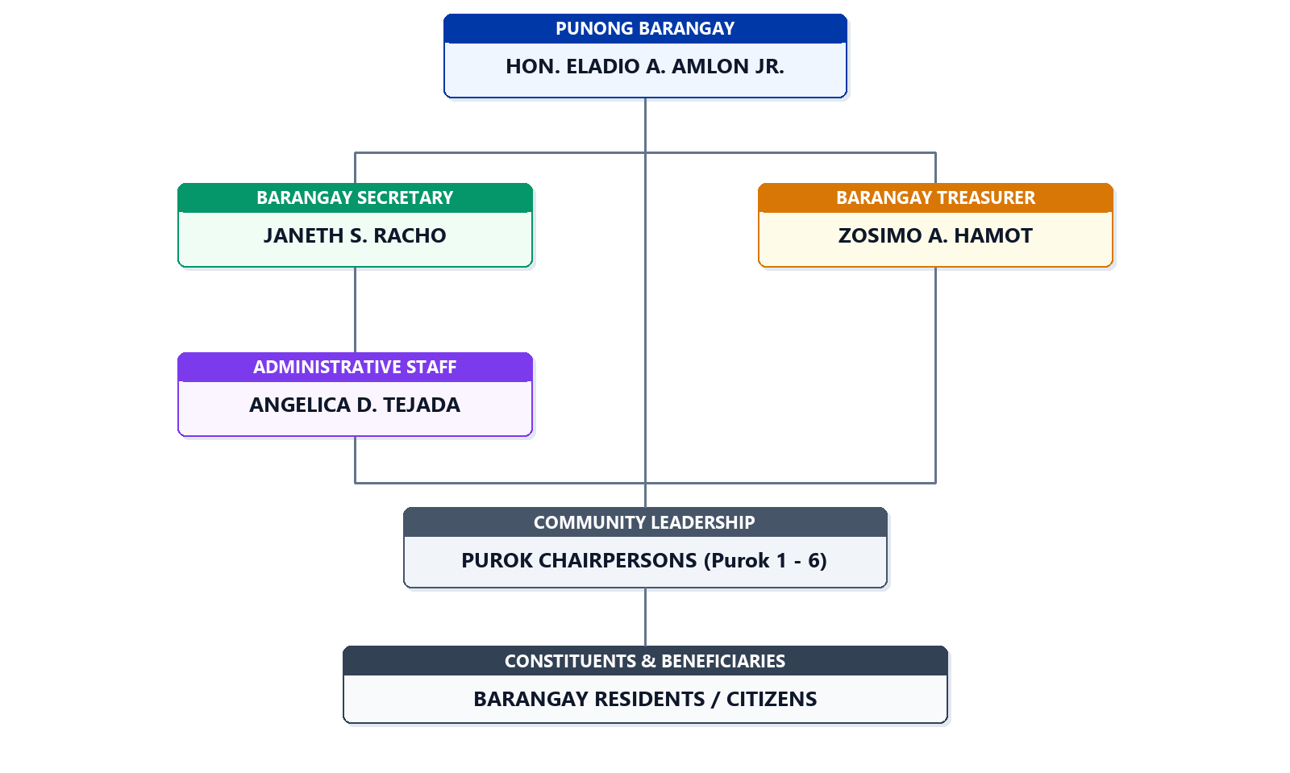
Figure 2: Organizational Chart
Requirements for Modeling
IPO Chart
Figure 3 shows the Input-Process-Output (IPO) chart that depicts the overall flow of CertiGuard: Secure Document Issuance and Verification Framework. The inputs are the information related to residents, certificate requests, administrative actions, and verification queries. The processes are the operations performed by the system, which include user authentication, certificate request processing, SHA-256 hash generation, QR code embedding, SMS notification, and third-party verification. The output is the end product obtained after processing, which includes issued certificates with QR codes, real-time SMS notifications, verification results, and administrative reports.
OUTPUT
- Issued Barangay Certificates with QR Codes
- Real-Time SMS Notifications
- Certificate Control Number
- Verification Results
- Secure Certificate Records
- Administrative Reports

INPUT
- Resident Information
- User Account Details
- Certificate Type
- Administrative Actions
- Verification Queries

PROCESS
- User Authentication
- Certificate Request Processing
- Administrative Reviews and Approval
- Certificate Generation
- SHA-256 Hash Generation
- QR Code Embedding
- SMS Notification
- Third-Party Verification
- Verification and Record Logging

Figure 3: Input-Process-Output Chart

Entity-Relationship Diagram
Figure 4 shows the Entity-Relationship Diagram (ERD), a graphical representation of how data is structured in the CertiGuard system. The diagram displays the entities, tables, attributes, and how they relate to each other. The ERD is used in database design to effectively plan and understand how data relates and interacts within the secure document issuance and verification framework.

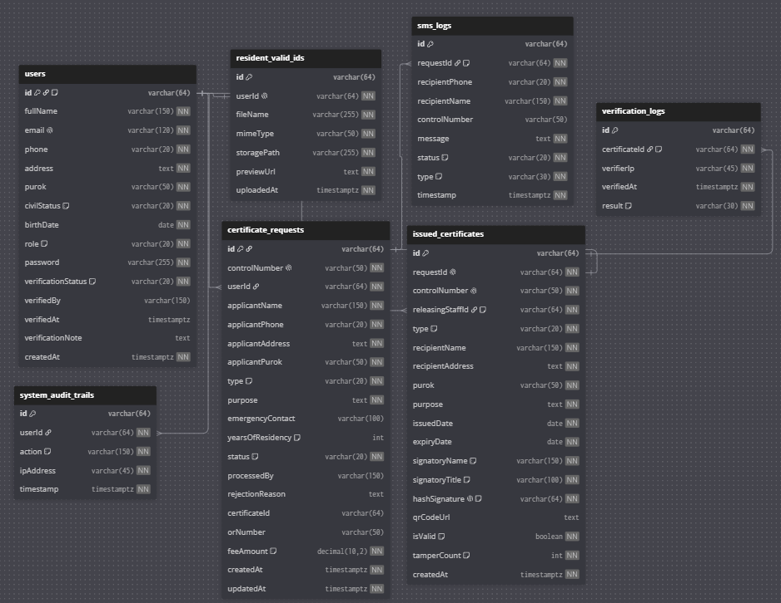
Figure 4: Entity-Relationship Diagram

Data Dictionary
The data dictionary of the system gives a detailed description of the data elements, data properties, and sources of data used in CertiGuard. This ensures that all data in the system is well-defined, managed, and consistent.
Table 1 displays the schema of the users table, storing account profile credentials for Barangay Residents, Barangay Captain (Admin), and Barangay Secretary/Staff. It manages residency status, contact information for SMS alerts, and verification status determined by administrative ID review.

Table 1: Users Table

Field Name | Data Type | Size | Description | Default | Constraints | Null | Key
Id | VARCHAR | 64 | Unique user ID identifier (e.g., user-admin-01, user-res-01) | None | Primary Key | No | PK
fullName | VARCHAR | 150 | Full legal name of the user | None | Required | No | --
Email | VARCHAR | 120 | Account email address used for signing in | None | Unique | No | --
Phone | VARCHAR | 20 | Contact mobile number for SMS notifications | None | Required | No | --
Address | TEXT | -- | Detailed house/street residential address | None | Required | No | --
Purok | VARCHAR | 50 | Assigned Barangay Purok/Zone (e.g., Purok 1 Centro) | None | Required | No | --
civilStatus | ENUM | -- | Civil status (Single, Married, Widowed, Separated) | None | Limited values | No | --
birthdate | DATE | -- | Date of birth | None | Required | No | --
Role | ENUM | -- | Account access role (resident, admin, staff) | None | Limited values | No | --
Password | VARCHAR | 255 | Hashed account credential password | None | Required | No | --
Verification Status | ENUM | -- | Residency verification status (pending, approved, rejected) | 'pending' | Limited values | No | --
verifiedBy | VARCHAR | 150 | Name of the Secretary/Admin who verified the resident | NULL | Optional | Yes | --
verifiedAt | TIMESTAMP | -- | Timestamp when registration was approved/rejected | NULL | Optional | Yes | --
Verification Note | TEXT | -- | Remarks/reasons provided during Secretary verification | NULL | Optional | Yes | --
createdAt | TIMESTAMP | -- | Timestamp when account registration was initiated | Current Timestamp | Required | No | --
Table 2 details the resident_valid_ids table, storing government ID attachments submitted by residents during online registration. This metadata enables authorized barangay personnel to confirm identity and residency prior to unlocking document issuance capabilities.
Table 2: Resident_Valid_Ids Table
Field Name | Data Type | Size | Description | Default | Constraints | Null | Key
Id | VARCHAR | 64 | Unique valid ID attachment identifier | None | Primary Key | No | PK
userId | VARCHAR | 64 | Foreign key referencing user account in users table | None | Foreign Key, Unique | No | FK, UK
fileName | VARCHAR | 255 | Original filename of the uploaded valid ID image | None | Required | No | --
mimeType | VARCHAR | 50 | Image MIME format (image/jpeg, image/png, image/webp) | None | Required | No | --
storagePath | VARCHAR | 255 | Supabase Storage cloud bucket file reference path | None | Required | No | --
previewUrl | LONGTEXT | -- | Base64 Data URL or public preview URL of uploaded ID | None | Required | No | --
uploadedAt | TIMESTAMP | -- | Timestamp when government ID was uploaded | Current Timestamp | Required | No | --
Table 3 presents the certificate_requests table, capturing citizen applications for Barangay Clearance, Certificate of Indigency, and Certificate of Residency, including administrative workflow status, official receipt details, and stated purposes.
Table 3: Certificate_Requests Table
Field Name | Data Type | Size | Description | Default | Constraints | Null | Key
Id | VARCHAR | 64 | Unique certificate request identifier | None | Primary Key | No | PK
controlNumber | VARCHAR | 50 | Sequential tracking control number (CG-TGR-2026-XXXX) | None | Unique | No | UK
userId | VARCHAR | 64 | Foreign key referencing applicant in users table | None | Foreign Key | No | FK
applicantName | VARCHAR | 150 | Snapshot of applicant full name at time of filing | None | Required | No | --
applicantPhone | VARCHAR | 20 | Mobile number receiving automated SMS status alerts | None | Required | No | --
applicantAddress | TEXT | -- | Residential address declared in certificate application | None | Required | No | --
applicantPurok | VARCHAR | 50 | Purok jurisdiction of applicant in Barangay Taguranao | None | Required | No | --
Type | ENUM | -- | Type of certificate (clearance, indigency, residency) | None | Limited values | No | --
Purpose | TEXT | -- | Certified legal, employment, or academic purpose | None | Required | No | --
emergencyContact | VARCHAR | 100 | Emergency contact information of applicant | NULL | Optional | Yes | --
yearsOfResidency | INT | -- | Declared duration of continuous barangay residency | 1 | Optional | Yes | --
Status | ENUM | -- | Processing status (pending, approved, rejected, ready) | 'pending' | Limited values | No | --
processedBy | VARCHAR | 150 | Name of admin/staff who reviewed the request | NULL | Optional | Yes | --
rejectionReason | TEXT | -- | Administrative remarks or reason if request is disapproved | NULL | Optional | Yes | --
certificateId | VARCHAR | 64 | Foreign key referencing issued certificate record | NULL | Foreign Key | Yes | FK
orNumber | VARCHAR | 50 | Official Receipt (O.R.) number or EXEMPT-INDIGENT | NULL | Optional | Yes | --
feeAmount | DECIMAL | 10,2 | Statutory document fee (PHP 0.00 / PHP 50.00) | 0.00 | Required | No | --
createdAt | TIMESTAMP | -- | Timestamp when certificate application was submitted | Current Timestamp | Required | No | --
updatedAt | TIMESTAMP | -- | Timestamp of last processing status change | Current Timestamp | Required | No | --
Table 4 outlines the issued_certificates table, maintaining immutable records of approved certificates. It includes the releasingStaffId foreign key tracking the releasing personnel, the official signatory name, and the 64-character SHA-256 cryptographic digital signature hash embedded in the verification QR code.
Table 4: Issued_Certificates Table
Field Name | Data Type | Size | Description | Default | Constraints | Null | Key
Id | VARCHAR | 64 | Unique issued certificate record identifier | None | Primary Key | No | PK
requestId | VARCHAR | 64 | Foreign key referencing originating certificate request | None | Foreign Key, Unique | No | FK, UK
controlNumber | VARCHAR | 50 | Official document tracking control number | None | Unique | No | UK
releasingStaffId | VARCHAR | 64 | Foreign key referencing staff/secretary who released document | None | Foreign Key | No | FK
Type | ENUM | -- | Certificate classification (clearance, indigency, residency) | None | Limited values | No | --
recipientName | VARCHAR | 150 | Legal recipient full name printed on certificate | None | Required | No | --
recipientAddress | TEXT | -- | Official residential address printed on certificate | None | Required | No | --
Purok | VARCHAR | 50 | Assigned Purok in Barangay Taguranao | None | Required | No | --
Purpose | TEXT | -- | Certified legal purpose printed on document | None | Required | No | --
issuedDate | DATE | -- | Date of official certificate issuance | Current Date | Required | No | --
expiryDate | DATE | -- | Validity expiration date (3 months or 6 months) | None | Required | No | --
signatoryName | VARCHAR | 150 | Name of issuing official (HON. ROBERTO D. DELA CRUZ) | HON. ROBERTO D. DELA CRUZ | Required | No | --
signatoryTitle | VARCHAR | 100 | Title of issuing authority (Punong Barangay) | 'Punong Barangay' | Required | No | --
hashSignature | VARCHAR | 64 | Immutable 64-char SHA-256 cryptographic digital hash | None | Unique | No | UK
qrCodeUrl | LONGTEXT | -- | Direct URL link embedded inside QR code for public verification | None | Required | No | --
isValid | BOOLEAN | -- | Document validity status flag (set to false if revoked) | TRUE | Required | No | --
tamperCount | INT | -- | Audit counter tracking invalid verification attempts | 0 | Required | No | --
createdAt | TIMESTAMP | -- | Timestamp when certificate record and hash were created | Current Timestamp | Required | No | --
Table 5 specifies the sms_logs table (formerly notifications), recording outbound transaction notifications dispatched via the automated SMS gateway. The table is linked via requestId foreign key to certificate_requests.id for rigorous relational integrity.
Table 5: SMS_Logs Table
Field Name | Data Type | Size | Description | Default | Constraints | Null | Key
Id | VARCHAR | 64 | Unique SMS gateway dispatch log identifier | None | Primary Key | No | PK
requestId | VARCHAR | 64 | Foreign key referencing originating certificate request | None | Foreign Key | No | FK
recipientPhone | VARCHAR | 20 | Citizen mobile number receiving SMS transaction alert | None | Required | No | --
recipientName | VARCHAR | 150 | Name of resident receiving notification | None | Required | No | --
controlNumber | VARCHAR | 50 | Associated certificate tracking control number | None | Optional | Yes | --
Message | TEXT | -- | Full SMS text content transmitted through gateway API | None | Required | No | --
Status | ENUM | -- | SMS delivery status: sent, delivered, failed | 'sent' | Limited values | No | --
Type | ENUM | -- | Classification: status_update, approved, rejected, security_alert | 'status_update' | Limited values | No | --
Timestamp | TIMESTAMP | -- | Timestamp when SMS notification was dispatched | Current Timestamp | Required | No | --
Table 6 defines the system_audit_trails table, establishing administrative accountability and forensic tracing for critical events, including user logins, request approvals, certificate revocations, and profile modifications.
Table 6: System_Audit_Trails Table
Field Name | Data Type | Size | Description | Default | Constraints | Null | Key
Id | VARCHAR | 64 | Unique system audit trail event identifier | None | Primary Key | No | PK
userId | VARCHAR | 64 | Foreign key referencing user/official in users table | None | Foreign Key | No | FK
Action | VARCHAR | 150 | Action description (e.g., LOGIN, APPROVE_REQUEST, REVOKE_CERT) | None | Required | No | --
ipAddress | VARCHAR | 45 | Client IPv4 or IPv6 network address of the user | None | Required | No | --
Timestamp | TIMESTAMP | -- | Timestamp when administrative action occurred | Current Timestamp | Required | No | --
Table 7 details the verification_logs table, recording public QR code scanning interactions and cryptographic fingerprint checks made through the public verification portal to detect and deter counterfeit documents.
Table 7: Verification_Logs Table
Field Name | Data Type | Size | Description | Default | Constraints | Null | Key
Id | VARCHAR | 64 | Unique public verification attempt identifier | None | Primary Key | No | PK
certificateId | VARCHAR | 64 | Foreign key referencing verified document in issued_certificates | None | Foreign Key | No | FK
verifierIp | VARCHAR | 45 | Client IP address of the scanning smartphone / device | None | Required | No | --
verifiedAt | TIMESTAMP | -- | Timestamp when public verification query was initiated | Current Timestamp | Required | No | --
Result | ENUM | -- | Verification outcome: authentic, counterfeit, revoked, expired | None | Limited values | No | --

Data and Processing Modeling
Context Diagram
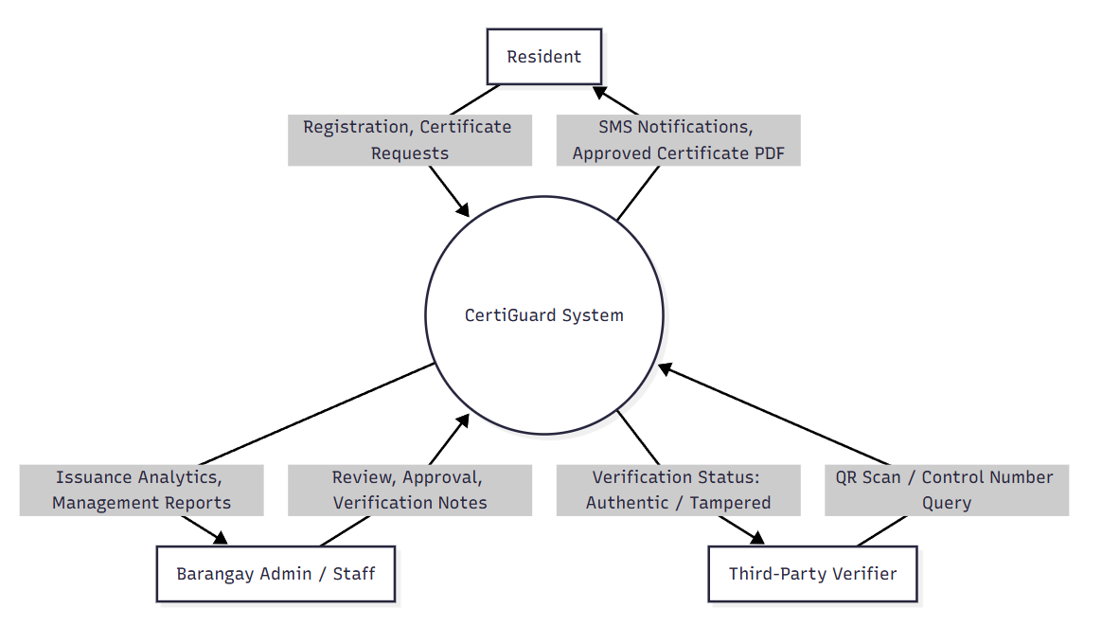
The context diagram depicts the interaction between CertiGuard: Secure Document Issuance and Verification Framework and its external entities, which are the Resident, Barangay Admin/Staff, and Third-Party Verifier. The system is depicted as a single process that receives input from the Resident in the form of registration details, certificate requests, and verification queries; from the Barangay Admin/Staff in the form of request processing, approval/rejection actions, and report requests; and from the Third-Party Verifier in the form of QR code scans or certificate number queries. The system then generates output in the form of issued certificates with QR codes, SMS notifications, verification results, and administrative reports.
Figure 5: Context Diagram

Data Flow Diagram
The Data Flow Diagram (DFD) depicts the flow of data in the CertiGuard system, showing how data is processed and how it relates to external entities such as the Resident, Barangay Admin/Staff, and Third-Party Verifier. The Resident performs actions such as registering, submitting certificate requests, and downloading certificates. The Barangay Admin/Staff maintains data in the system, such as processing requests, approving/rejecting applications, and generating reports. The Third-Party Verifier scans QR codes or inputs certificate numbers to verify authenticity. Data is stored in secure data stores including Users, Certificate Requests, Certificates, Notifications, and Verification Logs databases.
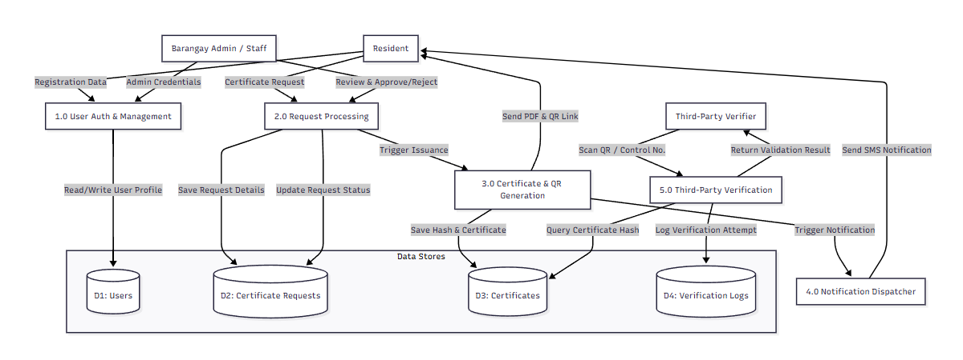
Figure 6: Data Flow Diagram
System Flow Chart
Figure 7 depicts the system flow chart of CertiGuard, highlighting the clear operational separation between authenticated administrative users and public verifiers. While Barangay Residents, Administrators, and Staff are required to authenticate via email and password to access their role-specific consoles, Third-Party Verifiers (such as employers, banks, and academic institutions) access the public verification portal directly without requiring credentials. Scanning the QR code on an issued certificate automatically routes the scanning device to the public verification module, querying the cryptographic ledger directly to produce an instant authentic badge or a counterfeit alert.
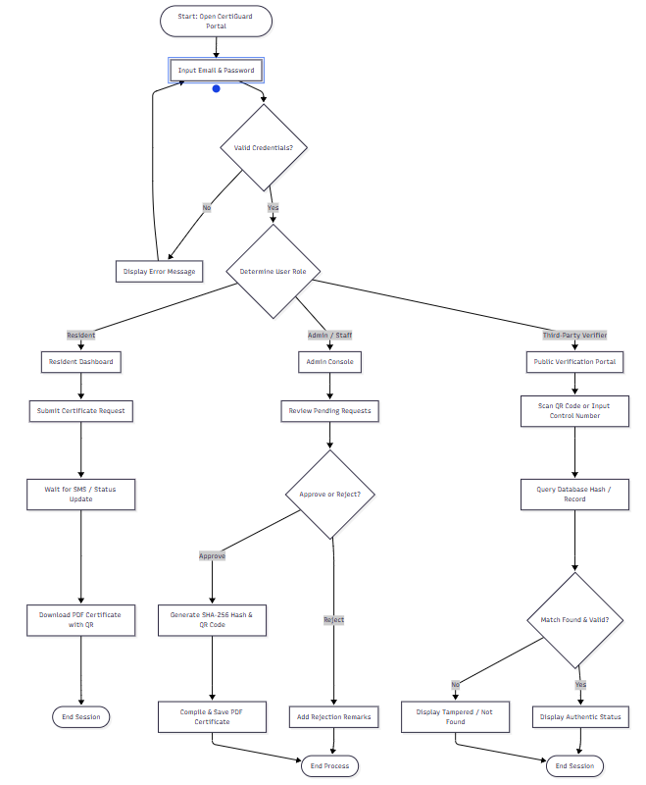
Figure 7: System Flow Chart

Disaster Recovery Plan
Table 8 shows the Disaster Recovery Plan (DRP) for CertiGuard, ensuring continuity of operations, protection of information, and quick restoration after unexpected failures.
Table 8: Disaster Recovery Plan
Goals | Potential Threats | Response / Recovery Plan
Protect data integrity and confidentiality | Hacking, data breaches, unauthorized access | Regular backups, encryption, role-based access control, audit logs
Ensure system accessibility | Internet outage, server crash, power failure | Cloud hosting via Supabase, backup internet, UPS, manual fallback procedures
Minimize operational downtime | Hardware/software failure, Supabase service disruption | System maintenance, redundant cloud infrastructure, quick restoration protocols
Maintain cryptographic verification integrity | SHA-256 hash collision, QR code tampering | Regular integrity checks, hash validation, secure database access
Secure SMS notification delivery | SMS gateway failure, network issues | Backup SMS gateway provider, retry mechanisms, manual notification fallback
Secure analytics and reports | Data corruption, unauthorized access | Automated backups, admin-only access, audit logs, role-based permissions

References
Adithia, M.T. (2026). Document verification and authentication by using password-based digital signatures with QR codes. JUTIF (Jurnal Teknik Informatika).
https://jutif.if.unsoed.ac.id/index.php/jurnal/article/view/5484
Arifin, Z. (2026). Development of a web-based TOEFL e-certificate system with QR code verification and AES–SHA-256 security framework. JISTECH (Journal of Information
Science and Technology), Athallah Publishing.
https://athallahpublishing.com/index.php/jistech/article/view/316
Boranbayev, A., et al. (2021). Development and design of a library information system intended for automation of processes in higher education institution. Journal of
Information and Communication Technology.
https://jtiik.ub.ac.id/index.php/jtiik/article/download/7319/1198/37619
Department of the Interior and Local Government. (2026, July 7). DILG inilunsad nationwide digital document management system para sa LGUs. Philippine Star. https://www.philstar.com/pilipino-star-ngayon/metro/2026/07/07/2540366/dilg-inilunsadnationwide-digital-document-management-system-para-sa-lgus
Echedom, A.U., & Okuonghae, O. (2021). Transforming academic library operations in
Africa with artificial intelligence: Opportunities and challenges. Journal of Library and Information Science. https://scispace.com/pdf/implementasi-sistem-otentikasi-dokumenberbasis-quick-3ayho3ekjm.pdf
International Journal of Engineering Research & Technology. (2026, May 15). Comparison of traditional and digital barangay systems in the Philippines. IJERT, 15(5).
https://www.ijert.org/comparison-of-traditional-and-digital-barangay-systems-in-thephilippines-ijertv15is050965
International Research Journals. (2026, May 5). Document verification system using QR code method. IRE Journals. https://www.irejournals.com/paper-details/1717324
Thaijo Journal. (2026, February 28). An academic extension-driven solution for enhancing barangay operations in rural Philippines. TSU Journal. https://ph02.tcithaijo.org/index.php/tsujournal/article/view/261914
Villanueva, L.G.V., Esteves, K.J.G., & De Guzman, K.D. (2026). Transforming local governance: Applying AI and data analytics through Barangay Information Management Systems. Springer. https://link.springer.com/chapter/10.1007/978-3-032-25187-9_39
eJournals Philippines. (2025). Digital Barangay: Ayos Lomboy's web-based management system for Barangay Yuson. eJournals PH, 21(1). https://ejournals.ph/article.php?id=30193

